**Chapter 10: AJAX, Dynamic Pages(6 videos, 4.15 hours)**

**Day1**

**Handling AJAX elements:**

<http://en.wikipedia.org/wiki/Ajax_%28programming%29>

**Ajax (also AJAX; pronounced /'e?d?æks/; an acronym for asynchronous JavaScript and XML)[1] is a group of interrelated web development methods used on the client-side to create asynchronous web applications. With Ajax, web applications can send data to, and retrieve data from, a server asynchronously (in the background) without interfering with the display and behavior of the existing page. Data is usually retrieved using the XMLHttpRequest object. Despite the name, the use of XML is not needed (JSON is often used instead), and the requests do not need to be asynchronous.[2]**

**Ajax is not one technology, but a group of technologies. Ajax uses a combination of HTML and CSS to mark up and style information. The DOM is accessed with JavaScript to dynamically display, and to allow the user to interact with the information presented. JavaScript and the XMLHttpRequest object provide a method for exchanging data asynchronously between browser and server to avoid full page reloads.**

**Application :kayak.com**

**TC001: AJAX dropdown1**

1. **Go to kayak.com**
2. **Go to flights**
3. **Enter “Los A” in the destination**
4. **Verify if the 1st name in the auto drop down is listed**

**The keys got so many options from the keyboard.**

@Test

**public** **void** testUntitled2() **throws** Exception {

driver.get(baseUrl + "/");

driver.findElement(By.*id*("origin")).clear();

driver.findElement(By.*id*("origin")).sendKeys("Sydney (SYD)");

Thread.*sleep*(1000);

driver.findElement(By.*id*("origin")).sendKeys(" ");

Thread.*sleep*(2000);

driver.findElement(By.*id*("origin")).sendKeys("A");

driver.findElement(By.*id*("origin")).clear();

Thread.*sleep*(2000);

//I want to code what happens when I hit the down arrow key to pick up from the auto drop list. These are sending the keyboard command to the application

driver.findElement(By.*id*("origin")).sendKeys(Keys.*ARROW_DOWN*); //This will select the drop down\

//This dint work wither as 1 arrow down is taking the label of the drop down. So I replaced down arrow with a tab so that it picks up the auto drop

Thread.*sleep*(2000);

//Next I want to enter the key. These are sending the keyboard command to the application

// driver.findElement(By.id("origin")).sendKeys(Keys.ENTER); This enter took the search, so instead of an enter,, I want to use keys.tab

driver.findElement(By.*id*("origin")).sendKeys(Keys.*TAB*);

Thread.*sleep*(2000);

System.*out*.println("City selectyed is" + driver.findElement(By.*id*("origin")).getAttribute("value"));

driver.findElement(By.*id*("destination")).clear();

driver.findElement(By.*id*("destination")).sendKeys("Lagos (LOS)");

}

TC002

**AJAX dropdown2**

1. **Go to kayak.com**
2. **Go to flights**
3. **Enter “Los A” in the destination**
4. **List all the results that appear in the Ajax Dropdown.**
5. **Repeat for different Keywords.**

**On the website, type a word in the search bar and it brings the drop down list and when I place my cursor over the drop down, it brings up this elements,**

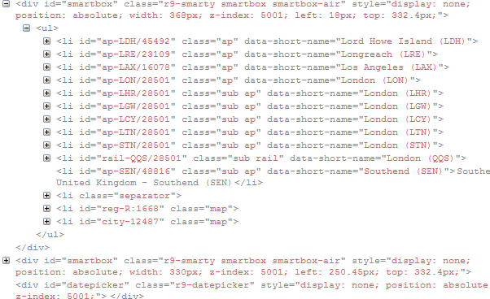

The ul and li are like the bullet points like in the word document. That’s how the code is written. It is only shows those specific elements,

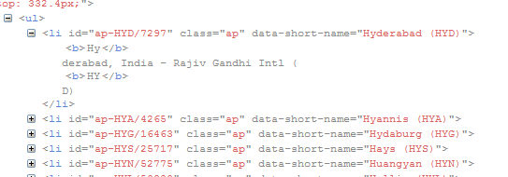

When I expand the li, it shows what was mentioned was mentioned. The whole syntax is here.

Copy the xpath of one of them and run the code

@Test

**public** **void** testUntitled2() **throws** Exception {

driver.get(baseUrl + "/");

driver.findElement(By.*id*("origin")).clear();

//code to list all the

driver.findElement(By.*id*("origin")).sendKeys("hy");

Thread.*sleep*(1000);

//capture all the items listed in the ajax drop down

System.*out*.println("city is"+ driver.findElement(By.*id*("ap-HYA/4265")).getText());

}

Results:

city isHyannis, MA, United States - Barnstable (HYA)

Day2

@Test

**public** **void** testUntitled2() **throws** Exception {

driver.get(baseUrl + "/");

driver.findElement(By.*id*("origin")).clear();

//code to list all the

driver.findElement(By.*id*("origin")).sendKeys("hy");

Thread.*sleep*(1000);

//capture all the items listed in the ajax drop down

System.*out*.println("city is"+ driver.findElement(By.*id*("ap-HYA/4265")).getText()); //This line will work only when isearch for Hy, if I search for D, this code will not work.

// All I need to do is capture the HYA specific city using id

//html/body/div[8]/ul/li[6] - This is the xpath code for one of the city in the drop down

String xpath1 = "//html/body/div[8]/ul/li["; //This is the first common path of the xpath

String xpath2 = "]";

String xpath3;

**for** (**int** i=1; i<7; i++){ //In this case I know how many elements are there

xpath3 = xpath1 + i + xpath2;

System.*out*.println("Ajax list" + i + "is" + driver.findElement(By.*xpath*(xpath3)).getText());

}

o/p:

city isHyannis, MA, United States - Barnstable (HYA)

Ajax list1isHyderabad, India - Rajiv Gandhi Intl (HYD)

Ajax list2isHyannis, MA, United States - Barnstable (HYA)

Ajax list3isHydaburg, AK, United States - SPB (HYG)

Ajax list4isHays, KS, United States - Hays (HYS)

Ajax list5isHuangyan, China - Huangyan (HYN)

Ajax list6isHollis, AK, United States - SPB (HYL)

@Test

**public** **void** testUntitled2() **throws** Exception {

driver.get(baseUrl + "/");

driver.findElement(By.*id*("origin")).clear();

//code to list all the

driver.findElement(By.*id*("origin")).sendKeys("hy");

Thread.*sleep*(1000);

//capture all the items listed in the ajax drop down

//html/body/div[8]/ul/li[6] - This is the xpath code for one of the city in the drop down

String xpath1 = "//html/body/div[8]/ul/li["; //This is the first common path of the xpath

String xpath2 = "]";

String xpath3;

//This is to know how many options are displayed in the ajax

**int** i = 1;

xpath3 = xpath1 + i + xpath2;

**while** (driver.findElement(By.*xpath*(xpath3)).isDisplayed()){

System.*out*.println("Ajax list is" + i + " is" + driver.findElement(By.*xpath*(xpath3)).getText());

i=i+1;

xpath3 = xpath1 + i + xpath2;

}

O/P:

city isHyannis, MA, United States - Barnstable (HYA)

Ajax list is1 isHyderabad, India - Rajiv Gandhi Intl (HYD)

Ajax list is2 isHyannis, MA, United States - Barnstable (HYA)

Ajax list is3 isHydaburg, AK, United States - SPB (HYG)

Ajax list is4 isHays, KS, United States - Hays (HYS)

Ajax list is5 isHuangyan, China - Huangyan (HYN)

Ajax list is6 isHollis, AK, United States - SPB (HYL)

Ajax list is7 isShow airports on map:

Ajax list is8 isHyères, France

DAY3

Calender box:

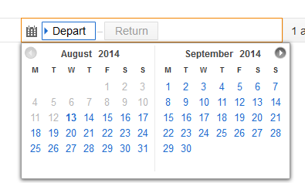

@Test

**public** **void** testUntitled2() **throws** Exception {

driver.get(baseUrl + "/");

driver.findElement(By.*id*("origin")).clear();

//code to list all the

driver.findElement(By.*id*("origin")).sendKeys("hyderabad");

driver.findElement(By.*id*("destination")).sendKeys("Sydney");

Thread.*sleep*(1000);

//capture the date options

//step1: click on the date field

driver.findElement(By.*id*("travel_dates-start-placeholder")).click();

Thread.*sleep*(3000);

//step2: capture the month/year

// for Month = /html/body/div[10]/div[2]/span[1]/span/span[1]

// for Year = /html/body/div[10]/div[2]/span[1]/span/span[2]

// /html/body/div[10]/div[3]/span[1]/span/span[1]

// /html/body/div[10]/div[3]/span[1]/span/span[2]

System.*out*.println("Month1 is" + driver.findElement(By.*xpath*("//html/body/div[10]/div[2]/span[1]/span/span[1]")).getText());

System.*out*.println("Year1 is" + driver.findElement(By.*xpath*("//html/body/div[10]/div[2]/span[1]/span/span[2]")).getText());

System.*out*.println("Month1 is" + driver.findElement(By.*xpath*("//html/body/div[10]/div[3]/span[1]/span/span[1]")).getText());

System.*out*.println("Year1 is" + driver.findElement(By.*xpath*("//html/body/div[10]/div[3]/span[1]/span/span[2]")).getText());

//step3 : capture the dates

}

}

O/P:

Month1 isAugust

Year1 is2014

Month1 isSeptember

Year1 is2014

Capturing Dates:

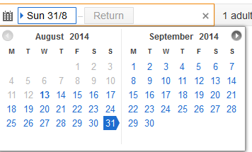

1 : /html/body/div[10]/div[2]/span[2]/span[2]/span[1]/span[5]/span

2 : /html/body/div[10]/div[2]/span[2]/span[2]/span[1]/span[6]/span

4 : /html/body/div[10]/div[2]/span[2]/span[2]/span[2]/span[1]/span

13: /html/body/div[10]/div[2]/span[2]/span[2]/span[3]/span[3]/span

18: /html/body/div[10]/div[2]/span[2]/span[2]/span[4]/span[1]/span

31: /html/body/div[10]/div[2]/span[2]/span[2]/span[5]/span[7]/span

String xp1 = "/html/body/div[10]/div[2]/span[2]/span[2]/span[4]/span[";

String xp2 = "]";

**for** (**int** i = 1; i<8; i++){

String xp3 = xp1 + i +xp2;

System.*out*.println("second row date is :" + driver.findElement(By.*xpath*(xp3)).getText());

}

o/p:

Month1 isAugust

Year1 is2014

Month1 isSeptember

Year1 is2014

second row date is :18

second row date is :19

second row date is :20

second row date is :21

second row date is :22

second row date is :23

second row date is :24

* The dates that are blank in first row and last row
* Xpath of row 1 blank field is

Code to select a date:

@Test

**public** **void** testUntitled2() **throws** Exception {

driver.get(baseUrl + "/");

driver.findElement(By.*id*("origin")).clear();

//code to list all the

driver.findElement(By.*id*("origin")).sendKeys("hyderabad");

driver.findElement(By.*id*("destination")).sendKeys("Sydney");

Thread.*sleep*(1000);

//capture the date options

//step1: click on the date field

driver.findElement(By.*id*("travel_dates-start-placeholder")).click();

Thread.*sleep*(3000);

//step2: capture the month/year

// for Month = /html/body/div[10]/div[2]/span[1]/span/span[1]

// for Year = /html/body/div[10]/div[2]/span[1]/span/span[2]

// /html/body/div[10]/div[3]/span[1]/span/span[1]

// /html/body/div[10]/div[3]/span[1]/span/span[2]

System.*out*.println("Month1 is" + driver.findElement(By.*xpath*("//html/body/div[10]/div[2]/span[1]/span/span[1]")).getText());

System.*out*.println("Year1 is" + driver.findElement(By.*xpath*("//html/body/div[10]/div[2]/span[1]/span/span[2]")).getText());

System.*out*.println("Month1 is" + driver.findElement(By.*xpath*("//html/body/div[10]/div[3]/span[1]/span/span[1]")).getText());

System.*out*.println("Year1 is" + driver.findElement(By.*xpath*("//html/body/div[10]/div[3]/span[1]/span/span[2]")).getText());

//step3 : capture the dates

//The following are the xpaths for blank fields: There is no spann at the end.

//html/body/div[10]/div[2]/span[2]/span[2]/span[1]/span[1]

//html/body/div[10]/div[2]/span[2]/span[2]/span[1]/span[2]

String xp1 = "//html/body/div[10]/div[2]/span[2]/span[2]/span[";

String xp2 = "]/span[";

String xp3 = "]";

**for** (**int** i =1; i<5; i++){

**for** (**int** j=1 ; j<8; j++){

String xp4 = xp1 + i + xp2 + j+ xp3;

**try**{

System.*out*.println("Date in row is " + i + "col" + j+ "is" + driver.findElement(By.*xpath*(xp4)).getText());

//This code clicked on a date.

**if** (i==4 && j==4){

driver.findElement(By.*xpath*(xp4)).click();

driver.findElement(By.*xpath*(xp4)).click(); //Some applications need double click for the app to be selected.

Thread.*sleep*(4000);

}

} **catch** (NoSuchElementException myErr){

System.*out*.println("Date in row is " + i + "col" + j+ "is BLANK");

}

}

Day4

**How can we capture information from a webtable**

* On the page select the place, date, uncheck the checkboxes and click search and find the prices.
* Unchecking the checkboxes.

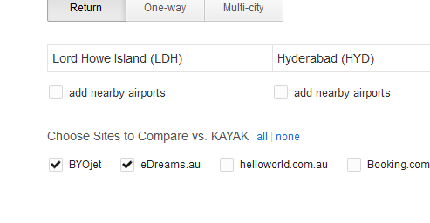

**package** recorded;

**import** java.util.concurrent.TimeUnit;

**import** org.junit.*;

**import** org.openqa.selenium.*;

**import** org.openqa.selenium.firefox.FirefoxDriver;

// irrespective of any input, it should bring up the list

**public** **class** checkboxes {

**private** WebDriver driver;

**private** String baseUrl;

@Before

**public** **void** setUp() **throws** Exception {

driver = **new** FirefoxDriver();

baseUrl = "http://www.kayak.com.au/";

driver.manage().timeouts().implicitlyWait(30, TimeUnit.*SECONDS*);

}

@Test

**public** **void** testUntitled2() **throws** Exception {

driver.get(baseUrl + "/");

Thread.*sleep*(3000);

driver.manage().timeouts().implicitlyWait(30, TimeUnit.*SECONDS*);

driver.findElement(By.*id*("origin")).clear();

//code to list all the

driver.findElement(By.*id*("origin")).sendKeys("Delhi");

driver.findElement(By.*id*("origin")).sendKeys(Keys.*DOWN*);

driver.findElement(By.*id*("origin")).sendKeys(Keys.*TAB*);

driver.findElement(By.*id*("destination")).sendKeys("Sydney");

Thread.*sleep*(1000);

//capture the date options

//step1: click on the date field

driver.findElement(By.*id*("travel_dates-start-placeholder")).click();

driver.manage().timeouts().implicitlyWait(30, TimeUnit.*SECONDS*);

Thread.*sleep*(3000);

driver.findElement(By.*xpath*("/html/body/div[10]/div[2]/span[2]/span[2]/span[4]/span[4]/span")).click();

driver.findElement(By.*xpath*("/html/body/div[10]/div[2]/span[2]/span[2]/span[4]/span[4]/span")).click();

Thread.*sleep*(3000);

driver.findElement(By.*id*("travel_dates-end-display")).click();

driver.findElement(By.*xpath*("/html/body/div[10]/div[3]/span[2]/span[2]/span[5]/span[2]/span")).click();

driver.findElement(By.*xpath*("/html/body/div[10]/div[3]/span[2]/span[2]/span[5]/span[2]/span")).click();

Thread.*sleep*(3000);

driver.manage().timeouts().implicitlyWait(30, TimeUnit.*SECONDS*);

//Uncheck checkboxes

Uncheck("cmp28620131_4_JCOXCWyQRQ");

Thread.*sleep*(1000);

Uncheck("cmp25215893_5_JCOXCWyQRQ");

Thread.*sleep*(1000);

Uncheck("cmp29524161_6_JCOXCWyQRQ");

Thread.*sleep*(1000);

Uncheck("cmp25215653_7_JCOXCWyQRQ");

Thread.*sleep*(1000);

driver.findElement(By.*id*("fdimgbutton")).click();

//Get prices and airlines

//Prices:

System.*out*.println(driver.findElement(By.*xpath*("//html/body/div[3]/div[1]/div/div[1]/div/div/div/div[3]/div[3]/div[8]/div[2]/div/div[1]/div[1]/div[1]")).getText());

driver.findElement(By.*xpath*("//html/body/div[3]/div[1]/div/div[1]/div/div/div/div[3]/div[3]/div[8]/div[3]/div/div[1]/div[1]/div[1]/a")).getText();

driver.findElement(By.*xpath*("//html/body/div[3]/div[1]/div/div[1]/div/div/div/div[3]/div[3]/div[8]/div[4]/div/div[1]/div[1]/div[1]/a")).getText();

//Airlines

driver.findElement(By.*xpath*("//html/body/div[3]/div[1]/div/div[1]/div/div/div/div[3]/div[3]/div[8]/div[2]/div/div[1]/div[2]/div[2]/div[2]")).getText();

driver.findElement(By.*xpath*("//html/body/div[3]/div[1]/div/div[1]/div/div/div/div[3]/div[3]/div[8]/div[3]/div/div[1]/div[2]/div[2]/div[2]")).getText();

driver.findElement(By.*xpath*("//html/body/div[3]/div[1]/div/div[1]/div/div/div/div[3]/div[3]/div[8]/div[5]/div/div[1]/div[2]/div[2]/div[2]")).getText();

}

**public** **void** Uncheck(String eid){

**if** (driver.findElement(By.*id*(eid)).isSelected()){

driver.findElement(By.*id*(eid)).click();

System.*out*.println("Now unchecked");

} **else** {

System.*out*.println("Already unchecked");

}

}

}